***BIOLOGY***

***SCHEME OF WORK S S ONE***

***Week 1 - Recognizing Living things***

***Week 2 - Living things and non-living things***

***Week 3 - Classification of Living things***

***Week 4 - Organization of life***

***Week 5 - Plant Nutrition***

***Week 6 - Nutrient cycling in Nature***

***Week 7 - Nutrition in Animals***

***Week 8 - Mode of Nutrition***

***Week 9 - Basic ecological concept***

***Week 10 -Growth, Irritability and Movement***

***WEEK ONE***

***BIOLOGY AND INQUIRY***

*Science is defined as a systematic process of making enquiry about the living things and non-living things in our environment. The term Biology is coined from two Greek work bios meaning life and Logos meaning study. Therefore Biology is simply defined as study of life i.e. study of living things or Biology is defined as science of life ranging from the unicellular organisms to the study of global interaction among millions of organisms that forms life. It involves the study of life history of individual organism as well as the collective history of all*

*Organisms. Biology is broadly divided into two:*

*(a) Zoology: which is the study of animal, their behavior, feeding and life history?*

*(b) Botany: is the study of different type of plant.*

*Some other specific aspects of Biology are:*

*Morphology, Anatomy, Physiology, Genetics, Ecology, Virology, Bacteriology, Microbiology, Taxonomy, Histology, Mycology, Embryology, Evolution e.t.c*

***SCIENTIFIC PROCESS OR APPROACH***

***Biology and Inquiry:*** *The knowledge of the nature and the role of inquiry to science. Inquiry in Biology enables us to acquaint ourselves with living things around us in a careful systematic manner. To understand these processes of enquiry, facts must be known through science. The orderly and systematic arrangement of facts is achieved through the process of science or scientific approach.*

*The scientific approach is a process of science which involves the process of making sequence of enquiries about an object or thing under study.*

*Scientific process begins with observation, followed by classification, inference, measurement, identification, hypothesis, experiment, control or conclusion, theory law or principle.*

*(i)* ***OBSERVATION****: This involves the use of human senses to describe an observation by using the characteristics and properties of material. The observation may lead to classification then to inference and later to measurement and identification of existing problems.*

*(ii)* ***HYPOTHESIS****: is defined as a sensible proposal or reasonable assumption or a scientific guess that can be subjected to verification or being tested.*

*(iii)* ***EXPERIMENT****: is defined as the process used for testing of hypothesis through experimentation during which data are collected. The data collected may lead to the development of new ideas. The process involves in experiment are as follows:*

*(iv)* ***AIM****: This is the purpose for which the experiment is carried out.*

*(v)* ***APPARATUS//MATERIALS****: These include the materials that will be used for the experiment.*

*(vi)* ***METHOD or PROCEDURE:*** *This is used to describe the details that are required step by step.*

*(vii)* ***RESULT:*** *This is the record of what is seen during and after the experiment.*

*(viii)* ***CONCLUSION****: This is used to finalize the outcome of the whole experiment*

*The end of the experiment can be used to show whether the hypothesis is true or false. If the subsequent experiments shows that the hypothesis is false, the whole idea or concept of the matter under investigation is then repeated or rejected. But when the hypothesis is true after several repeated experiment it is accepted and becomes a THEORY.*

***A THEORY*** *is a tested hypothesis that has been confirmed to be true. By the time the theory is extensively tested and proven to be true, it becomes a LAW OR PRINCIPLE*

***WEEK TWO***

***LIVING THINGS AND NON-LIVING THINGS***

*Living things are those objects that have life e.g. plant and animals.*

*Non-living things are those objects without life or lifeless objects.*

***CHARACTERISTICS OF LIVING THINGS***

*1.* ***MOVEMENT:*** *is defined as the ability of a living organism to move its own body or part of its body from one place to another. Living things move for the following reasons:*

*- To look for food*

*- To run away from danger*

*- To seek mate in time of reproduction*

*- To respond to external stimuli*

*2.* ***NUTRITION:*** *is defined as the ability of living organism to feed to enable them living to be able to carry out life functions such as growth, respiration and reproduction. Living things use two method of nutrition*

* *Autotrophic/halophytic nutrition: It is a method used by all green plants and some bacteria which involve manufacturing of their own food from simple inorganic compound through a process of photosynthesis.*
* *Heterotrophic/holozoic nutrition: it is a method strictly used by animals to obtain food from the product of plant. They depend on the food produced by plant directly or indirectly since they cannot manufacture theirs.*

*3.* ***RESPIRATION:*** *is defined as a process in which food substances within cell of living organism is oxidized in the presence of oxygen to release energy for all life process*

*4.* ***EXCRETION:*** *This is defined as the removal of poisonous metabolic waste products from the body or cells of living organism if not excreted will damage the body cells. Metabolism is the sum total of the chemical processes which take place within the cells of the body of the organisms.*

*5.* ***GROWTH:*** *is defined as a permanent increase in body and mass of an organism or increase in body complexity as a result of cell division and cell differentiation. Good feeding will enhance increase in body mass.*

*6.* ***IRRITABILITY/SENSITIVITY:*** *is defined as the ability of an organism to respond to changes in both internal and external stimuli to include: heat, light, pain, water, sound and chemical substances to which living things respond to.*

*7.* ***REPRODUCTION:*** *This is the ability of living organisms to give rise to new offsprings which have the same characteristics as their parents. Reproduction ensures continuity of the species.*

***Types***

***i.*** *Sexual reproduction: This involves two organisms of the same species to produce a new offspring*

*ii. Asexual reproduction: It involves only one organism to produce another offspring of their kind.*

*8.* ***ADAPTATION:*** *is defined as the way in which living organism get used to their various environment in such a manner that they are comfortable in order to survive.*

*9.* ***COMPETITION:*** *This is the ability of living things to struggle for all the necessities of life in order to survive in their various environment. Living things compete for food, light, space, water, mates etc. in order to survive and be in continuous existence.*

*10.* ***DEATH:*** *All living things must die because they have a definite and limited period of existence.*

***Differences Between Plants and Animals***

*Plants Animals*

*1. Plant growth in indefinite and apical Animal growth is definite and interacting meaning*

*it occurs uniformly in their body*

*2. Plant has a slow response to external Animal shows a fast response to external stimuli*

*Stimuli*

*3. Plant stores food as starch except in Animal stores food as glycogen*

*fungi*

*4. Plant has no specialized sense organs Animal has specialized sense organ*

*5. Plant has no fixed number of parts, Animal has fixed number of parts which are usually*

*Always continue compact.*

*6. Gaseous exchange in plant is through Gaseous exchange is through special organ*

*the entire body*

*7. Plant cell has a rigid cellulose all wall Animal cell has a flexible living cell membrane*

*8. Plant cell has large vacuole containing Animal cell has small or no vacuole*

*sap*

*9. Plant feed autotrophic ally Animal feeds heterotrophic ally*

*10. Plant processes no special excretory Animal possesses well developed excretorysystem*

*Organ*

***Microscope (Parts and function)***

*A Microscope is an instrument used to view or magnify organisms smaller that 0.001mm which cannot be seen by human naked eyes. A microscope is made of the following parts.*

*(i)* ***Eye piece lens or ocular*** *(x10) is used for viewing a magnified object.*

*(ii)* ***Body tube:*** *It provides attachment to eyepiece and revolving nose piece*

*(iii)* ***Revolving nose piece*** *is used for selecting objective lenses to be used and to be in line with the eyepiece*

*(a).* ***Low power objective lens****(x4) is used for the lowest magnification of an object*

*(b)* ***Medium power objective lens*** *(x10) it magnifies object more than low power objective lens*

*(c)* ***High power objective lens*** *(x40). It is used for the highest magnification of object for minute detail*

*(iv)* ***Coarse focus knob****: it is used for focusing an object at low power*

*(v)* ***Fine adjustment knob:*** *it is used for focusing object at medium and high power magnification so that object is sharper at focus*

*(vi)* ***Arm***  *is used for lifting or carrying the microscope*

*(vii)* ***Stage:*** *is for displaying slide and specimens under focus*

*(a)* ***Clips****: are the stage for holding glass slide on the stage*

*(b)* ***Hole****: is present on the stage for light source to the viewing object*

*(viii)* ***Condenser:*** *it is used to regulate the amount of light rays entering the microscope and object*

*(ix)* ***Mirror****: it is used for collecting light rays and directing them to the condenser and object.*

*(x)* ***Base of the microscope-*** *is for balancing it on the table*

*DIAGRAM OF A MICROSCOPE*

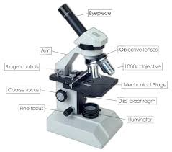

***ASSIGNMENT***

***WEEK ONE AND TWO***

*1. Which of the following groups embraces the rest?*

*(a) Class (b) Kingdom (c) Phylum (d) Species*

*2. Which of the following characteristics is not possessed by most plants? Ability to*

*(a) move away from stimuli (b) respire (c) reproduce (d) adapt to the environment*

*3. Carbohydrates are stored in animal cells in form of (a) starch (b) glycogen*

*(c) maltose (d) plastids*

*4. All living organisms (a) photosynthesis (b) respire (c) move (d) transpire*

***ESSAY***

*(5) State five differences between plant and animal*

***WEEK THREE***

***CLASSIFICATION OF LIVING THINGS***

*Classification is defined as the arrangement of living things into groups based on structural genetic and cellular organization. This is called* ***TAXANOMY.***The system of classification of living things used today is based on that introduced by Swedish naturalist named Carl Von Linne(1707-1778).His name was better known in Latin as Carolus Linnaeus.He published the classification of plant 1753 and that of animal in 1758.

*Living things are first separated into large group called* ***KINGDOM****. The division of kingdom smaller group called* ***PHYLA (PHYLUM****). The term division rather than phylum is usually used for plant. Phyla are divided into smaller groups called* ***CLASSES.*** *Each class* is *further divided into* ***ORDER****. Orders are further divided into smaller unit called FAMILIES. Families are again divided into* ***GENERA*** *(genius). A genius is broken into* ***SPECIES.*** *A species is a population of related organism that can interbreed within themselves to produce a fertile offspring. Genius is a group of closely related species. A family is a group of genera. An Order is a group of related families. A class is a group of related order. A phylum is a group of related classes. A kingdom is a group of related phyla.*

*Kingdom*

*Phylum or Division*

*Class*

*Order*

*Family*

*Genius*

*Species*

*Living things according to modern classification system which is based on physiology, biochemistry and embryology are classified into five kingdoms; MONERA, PROTOCTISTA, FUNGI, PLANTAE AND ANIMALIA.*

***MONERA (Characteristics****. They lack organized DNA i.e. the Deoxyribonucleic acid (DNA) is scattered in the cytoplasm an not in nucleus hence they are called prokaryotes.*

*ii. They have no mitochondrion in their cytoplasm*

*iii. Their cell wall lack cellulose, their cell wall is made up of protein and fatty materials*

*iv. They are microscopic single called organism*

*v. Some are motile while some are non-motile*

*vi. They feed both auto tropically and heterotrophic ally. Blue green bacterium & blue green algae*

*vii. The reproduce only by asexual mean.*

***KINGDOM PROTOCYISTA (Characteristics)***

*i. They have well organized DNA in the nucleus bounded by nuclear membrane hence they are called eukaryotes*

*ii. They are single called organism or unicellular organism*

*iii. Some are motile while some are non-motile*

*iv. They live in water, damp soil, leaf litter and other terrestrial habitats that have sufficient moist.*

*v. All protists use mitochondrion for cellular respiration*

*vi. They form cyst to survive adverse condition*

*vii. They all reproduce both sexually and asexually Examples are Amoeba, Euglena, Chlamydomonas, Plasmodium.*

*Example of Monera are: bacteria and photosynthetic blue green bacterium also known as blue green algae.*

***KINGDOM FUNGI (Characteristics)***

*i. They all feed heterotrophic ally because they lack chlorophyll therefore cannot photosynthesize.*

*ii. They are simple multicellular organism that grow like plant but are not plant because they are not green in colour.*

*iii. Their bodies are not divided into true root, stem and leaves*

*iv. They are mostly non-motile organisms composed of thread-like multinucleate hyphae collectively known as mycelium*

*v. They reproduce by means of spores. Spores are unicellular microscopic structure that is capable of germinating to a new organism.*

*vi. The fungi stores carbohydrate as glycogen just like animal not as starch as done by plant*

*vii. Their cell wall is made up of chitin and not cellulose like plant*

*Examples are Mucor, Rhizopus, Mushroom and Slime mould.*

***KINGDOM PLANTAE (Characteristic)***

*i. They are multicellular and non-motile organisms*

*ii. Their cells are bounded by rigid cellulose cell walls external to cell membrane*

*iii. They contain chlorophyll that enables them to manufacture their own food by photosynthesis*

*iv. Most plants store carbohydrates as starch or sucrose.*

***CLASSIFICATION OF KINGDOM PLANTAE BASED ON BOTANICAL CLASSIFICATION***

*The kingdom plantae is divided into four main phyla or Division*

*(i) Thallophyta (algae)*

*- They are simple microscopic plant*

*- They have no true root, stem and leaves*

*- They are found in aquatic habitat*

*-They are autotrophic plant i.e. They can synthesize their own food*

*- They reproduce both by asexual means and sexual means*

*- They have cellulose cell wall*

*- Many of them are pigmented such as red, blue, brown in addition to chlorophyll.*

*- Some are filamentous (algae) and the cells are not differentiated into tissue*

*(ii) Bryophyte (Moss and liverwort)*

*- They are non-vascular multicellular plant*

*- They have chlorophyll as the only photosynthetic pigment*

*- They are terrestrial but grow in moist environment*

*- Their body is differentiated into stem-like and leaf-like structure but no true root, stem and leaves*

*- They have no vascular tissue therefore they are unable to transport food and material round the body*

*- They reproduce asexually by means of spores while sexual reproduction by gametes and it takes place in water*

*- They exhibit what is called alternation of generation.*

*Division Pteridophyta (ferns)*

*- Their body is divided into true root, stem and leaves*

*- They have well developed vascular bundles comprising of xylem and phloem*

*- The underground stem is rhizome*

*- They reproduce by means of spores*

*- They need water of sexual reproduction which is by gametes formation*

*- The plants are mostly terrestrial while few are aquatic*

*- They exhibit alternation of generation*

*- They have asexual reproductive organ called sori while the sexual reproductive organ is heart- shaped called prothalus*

*SPERMATOPHYTA*

*- They are seed bearing plant*

*- They have well-developed vascular bundles*

*- They are well-adapted to terrestrial habitat and they are the most successful land plants*

*The Spermatophyta are divided into two:*

*(i) Division Gymnospermatophyta or Coniferophyta*

*- They are large plant with well-developed vascular bundle with true root, stem and leaves*

*- Their leaves are green in colour, small and needle-like*

*- Their naked seeds are born in cone because there is no ovary and no fruit*

*(ii) Division Angiospermatophyta*

*- They possess true flowers for sexual reproduction*

*- They have well-developed true root, stem and leaves*

*- They have well-developed vascular bundles*

*- Seeds and fruits are produced after fertilization and the seed are enclosed within the ovary*

*- They are terrestrial but some are aquatic*

*- They are terrestrial but some are aquatic*

*The Angiospermatophyta is divided into two classes*

*i. Monocotylenoneae (Monocot)*

*ii. Dicotyledoneae (Dicot)*

*Monocotyledoneae Dicotyledonea  
i. Leaves have parallel veins Leaves have network veins*

*ii. Flowers are generally dull in colour Flowers are bright in colour*

*iii. Embryo has one cotyledon (one seed Embryo has two cotyledons (two seed- leaves)*

*Leaf*

*iv. The size of cortex is narrow The size of the cortex is wide*

*v. It has fibrous root system It has tap root system*

*vi. Cambium is absent in the stem Cambium is present in the stem*

*vii. Vascular bundles are scattered all Vascular bundle are arranged in a ring of cambium*

*over the ground tissue*

*Example Maize, palm tree, grasses Examples are Mango, Orange.*

***CLASSIFICATION OF PLANTS BASED ON AGRICULTURE***

*Agricultural classification is the grouping of plants according to the product for which they are cultivated or grown*

1. **CEREALS OR GRAIN CROPS**: These are crops which are cultivated for their grain. They have high starch content. Examples are maize, guinea corn, millet, wheat, ryes, barley and oats.

*ii.* ***LEGIUMOUS PLANT OR POD****: These are important plants which contain high protein content. They are source of nitrate in the soil. Examples are groundnut, beans, melon, flamboyant, crotalaria e.t.c.*

*iii.* ***ROOT CROPS****: These are plant which are tuberous and are specialized for food storage. They are good source of carbohydrate. Examples are sweet potatoes, irish potatoes, yam, cassava and carrot iv.* ***VEGETABLE CROPS****: These are herbaceous plant which are important constituents of a diet. They serve as source of vitamins and mineral salts. Examples are tomatoes, pepper, onions, cabbage, lettuce, okra and vegetables.*

*v.* ***FRUITS****: These are plants that are grown for production of fruits\. Fruits are rich sources of vitamin A, C and minerals. They are usually eaten in their natural form (raw). They include mangoes, pawpaw, guava, bananas, and pineapple e.t.c.*

*vi.* ***CASH CROP (ECONOMIC CROP****): These are crops grown mainly for the purpose of money making. They include oil producing plant e.g. oil palm, latex crop e.g. rubber, fibre crop e.g. cotton, beverage and drug plants e.g. cocoa and spices.*

*vii.* ***OIL PLANT****S: These are plants that produce oil as food reserve and store it in their fruit or seeds. Example are palm oil fruit and kernel, seed of melon, cotton seed, groundnut, coconut and shea butter.*

*viii.* ***FIBRE CROPS****: These are crops that \are grown for their fibres that are used for making clotting, ropes, sacks e.t.c.*

*ix.* ***BEVERAGES AND DRUG PLANT:*** *These are crops that produce non-alcoholic beverages e.g. cocoa, coffee.*

*x.* ***QUININE****: is a drug that is obtained from the bark of cinchona spp. It is an anti-malaria drug extracted from plant.*

*xi.* ***SPICES****: These are vegetables plants that are used to add flavour and taste to modern dishes. Examples are ginger, cloves, pepper, vanilla, nutmeg.*

***Classification of Plant based on life cycle***

*1.* ***ANNUAL****: These are plants that have one growing season. They produce seeds during the first year of growing and then die off. Examples are maize, Guinea corn, wheat, groundnut, bean e.t.c*

*2.* ***BIENNIALS****: These are plants that grow for two seasons. The first year constitutes the vegetable stage during which the store of food material is built up and seeds are produced in the second year e.g. cabbage, carrot, cocoyam, cassava e.t.c.*

*3.* ***PERENNIALS****: These are plants that grow for three or more seasons or years e.g. shrub and three.*

***Relevance of Biology to Agriculture***

*Agriculture is defined as an act of growing crops and rearing farm animals to provide man’s basic need for*

*(i) Food (ii) Shelter (iii) Clothing (iv) Materials for industrial purposes*

***KINGDOM ANIMMALIA (Characteristic feature)***

*i. All are multicellular organisms*

*ii. DNA is located in nucleus enclosed with nuclear membrane*

*iii. Cells have no cell walls*

*iv. All possess nervous systems except the sponges*

*v. All possess true tissue except sponges*

*vi. Feeding is heterotrophic*

*The Kingdom is divided into two major groups*

*(i) INVERBRATA: These are groups of animal without backbone*

*(ii) VERTEBRATA: These are groups of animal that have backbone*

*The classification of animals into smaller categories is based on features such as:*

*(i) Body Symmetry*

*(ii) Body design*

*(iii) Body cavity*

*Body symmetry is based on the fact that the body of the animal has similar or corresponding parts in size, shape and position on opposite sides of a dividing line or a median plane*

***Types***

*1. Radial symmetry means the body of the animal can be cut along its axis in any place to give two identical halves*

*ii. Bilateral symmetry means the body of the animal can be cut along its axis in only one place to give two identical halves.*

*Body design is the way the body of the animal is shaped or framed whether it has one or two exits*

*i.* ***Sac-like body design****: Those animals that have single opening (mouth) that lead to the gut cavity*

*ii.* ***Tubular body design****: Those animals have double opening like tube with gut opening at the anterior (mouth) and posterior (anus)*

***Body Cavity:*** *A developing embryo of animal has primary layer of cell called germ layer differentiated to form various body parts. The tissue of primitive animals are derived from two layers of cells, the ectoderm and endoderm such animal is called Diploblastic animal e.g. Hydra.*

*Most animals are derived from three germs layers ectoderm, mesoderm and endoderm, such animal are called triploblastic animal.*

*Animal that have three germ layers can be further derived into:*

*i.* ***Acoelomate****: animal without body cavity*

*ii.* ***Pseudo coelomate****: animal with false body cavity*

*iii.* ***Coelomate****: animal with true body cavity*

***The member of phylum invertebrate***

*1.* ***PORIFERA*** *(Characteristic features)*

*- These are unicellular aquatic animals that usually attached to rocks or shell of other animals in colonies*

*- They are primitive animals that lack specialized tissue such as organs or system*

*- They have radial symmetry*

*- They have a single opening leading to internal cavity*

*Examples are the sponges which are vase-shaped with a symmetrical body.*

*2. Phylum* ***CNIDARIA OR COELENTERATA***

*The coelenterates are aquatic organisms which includes the sea anemone, jelly fish and corals which are marine organism, but hydra is found in fresh water*

*Characteristics*

*- They are multicellular organism*

*- They have radial symmetry*

*- They have only one body cavity called enteron*

*- They have two distinct body layers (diploblastic) ectoderm and endoderm.*

*- They have soft – jelly like bodies*

*- They reproduce asexually by budding*

*- They have one opening called mouth, no anus*

*- They have tentacles and stinging cells used for capturing their preys (Nematocyst)*

*- They have specialized cells such as nerve sensory and absorptive cells.*

*3. Phylum* ***Platyhelminthes*** *(Flatworm)*

*This group consists of the flatworms such as the planaria, flukes and tapeworms.*

*Characteristics*

*- They possess soft, flat and unsegimented body*

*- They have bilateral body symmetry*

*- They have no body cavity or lumen*

*- Their bodies is made up of three layers (triploblastic) ectoderm, mesoderm and endoderm*

*- Most flatworms are hermaphrodites and reproduce sexually*

*- Some of them are parasites in man and other animals*

*4. Phylum* ***Nematoda*** *(Round worms)*

*The nematodes are the hookworms, Ascaris lumbricoides and guinea worms*

*Characteristics*

*- They have round and cylindrical bodies*

*- They lack body cavity i.e. they have pseudo- coelom body cavity*

*- They have bilateral body symmetry*

*- Some are hermaphrodites while some reproduce sexually.*

*5. Phylum* ***Annelida***

*The annelids are the earthworm, leeches ad tubeworms*

*Characteristics*

*- They have a true body cavity or coelom*

*- They have a metameric segmentation which means their body is both internally and externally segmented, a feature which distinguish them from flat worms. Metameric segmentation means that body is divided into segments by position but have identical organ.*

*- some are aquatic while others are terrestrial*

*- Annelids reproduce sexually and many are hermaphrodites*

*- They are triploblastic animals*

*6. Phylum* ***Mollusca***

*The member of this phylum includes squid, mussel, periwinkles, snails, oyster, octopus and slug.*

*Characteristics*

*- They have soft-unregimented body*

*- They have tentacles on their heads*

*- They possess muscular foot adapted for crawling or borrowing*

*- Their body is covered by soft-tissue called mantle*

*- Some of them have calcerous shells e.g snail while some are without e.g. octopus*

*- Some are aquatic while some are terrestrial*

*- They have oculiferous tentacles which are used for sensitivity*

*7. Phylum* ***Arthropoda***

*This is the largest group in animal kingdom they have a distinct head with complex muscular system. The phylum is divided into four classes*

*a.* ***Crustacea***  *e.g. crab, crayfish, prawn, lobster.*

*b.* ***Insecta*** *e.g. all insects grasshopper, ant, termite e.t.c.*

*c.* ***Arachnida*** *e.g. spider, scorpion, miles and tick*

*d.* ***Myriapoda*** *e.g. centipede and millipede*

*Characteristics*

*- They have segmented bodies*

*- They have hard, rigid exoskeleton made of chitin bodies*

*- They have jointed appendages or jointed legs used for feeding, movement, reproduction or as sensory organs.*

*- They exhibit moulting or ecdysis i.e. shedding their exoskeleton at interval to permit growth*

*- Their bodies are divided into two or three segments such as head, thorax and abdomen which may be fused together in some member.*

*- They have bilateral body symmetry*

*- They are triploblastic animal*

*- They have various means of respiration e.g. gills, trachea, lung book or body surface.*

*8. Phylum* ***Echinodermata***

*These are the starfish, sea urchins, sea cucumbers and bristle star*

*Characteristics*

*- They have a radial body symmetry*

*- They are mostly marine*

*- They are triploblastic animals*

*- They have neither nor brain*

*- Their body is not segmented*

*- They have true feet which are used for movement*

***VERTEBRATA***

*This is a sub phylum of the phylum chordate. It comprises of five classes. They are:*

*PISCES (fishes)*

*AMPHIBIA (Amphibians)*

*REPTILIA (Reptiles*

*AVES (all birds)*

*MAMMALIA (mammals)*

***General Characteristics of Vertebrate***

*- They possess an internal jointed skeleton made up of cartilage or bone*

*- They all have bilateral symmetry*

*- The body is divided into head, trunk and tail*

*- They have two pairs of limbs (pectoral and pelvic) limbs.*

*- They have well- developed central nervous system with brain*

*- They have a closed blood system*

*- They possess skin which may be naked or have a covering of scales, feathers or hairs.*

*1.* ***CLASS PISCES*** *(OSTERITHY)*

*The Pisces include all group of fishes, they show good adaptation to aquatic life. Fishes are of two types*

*a. Bony fish: These are fishes with bony skeleton e.g. Tilapia, Salmon, Mackerel e.t.c.*

*b. Cartilagenous fish: These are fishes whose bones are soft e.g. dry fish, shark, rays e.t.c.*

*Characteristics*

*- The body is covered by scales but few are without scales*

*- They possess fins which are used for movement in water*

*- They use gills for gaseous exchange*

*- They are poikilothermic or cold blooded animal meaning that their body temperature varies with that of their environment*

*- They have swim bladder for buoyancy*

*- They have lateral line for detection of vibration*

*- They have streamlined body shape for easy movement in water*

*- They are oviparous animal meaning that they lay egg which develop to adult stage outside the body of the female*

***CLASS AMPHIBIA***

*They are the first vertebrates to adapt to life on land and water. The member includes toad, frogs, salamander and newts*

*Characteristics*

*- They are poikilothermic animal*

*- They have two pairs of limbs-fore limbs and hind-limbs.*

*- They have naked or moist glandular skin with no external scales*

*- They exhibit dual life i.e. they can live both on land and water*

*- They carry out gaseous exchange with gills at tadpole stage of life and with lungs, skin and mouth at adult stage*

*- They are oviparous using external fertilization*

***CLASS REPTILIA***

*The reptile includes all reptiles with dry skin with scales or bony plate which resist loss of water from the body. They are the first animal to have a copulatory organ (penis) for the purpose of internal fertilization. Examples are crocodile, lizard, wall gecko, snake e.t.c.*

*Characteristics*

*- They are poikilothermic animals*

*- They have dry skin covered with scales*

*- They all breathe with lungs*

*- They are oviparous animal*

*- They have homodont dentition meaning having set of teeth that are the same in shape and function.*

*- They use sexual reproduction with internal fertilization*

*- Some are aquatic animal e.g. crocodile and turtle while others are terrestrial*

***CLASS AVES (Birds)***

*The avers include all types of birds. They are mostly adapted to aerial life by means of wing which is a modification of the fore-limb. Examples of birds are pigeon, domestic fowls, ostrich, duck e.t.c.*

*Characteristics*

*- They are homoeothermic or warm blooded animal meaning they have a constant body temperature, it doesn’t change even when the temperature of its environment rises.*

*- The entire body of a bird is covered with feathers except the bird legs which are covered with scales*

*- The mouth is extended to form the beak which is used for feeding*

*- They have rigid hollow bones with air sac which make them light during flight*

*- They use internal fertilization*

*- They use lungs for respiration*

*- The fore-limbs modified to wings which are used for flight*

*- They are toothless but use beak for feeding*

***CLASS MAMMALIA (all mammals)***

*The mammals are the most advanced in the animal kingdom. They have two body cavities which is divided into two by a muscular sheet called diaphragm*

***Characteristics***

*- They are homoeothermic animal*

*- Their bodies are covered with hairs or furs*

*- They have heterodont dentition meaning having a set of teeth that are different in shape and function*

*- Their thoracic cavity is separated from the abdominal cavity by diaphragm*

*- They use lungs for respiration*

*- They have well developed brain*

*- They have external ear called pinnae*

*- They are viviparous made of reproduction meaning they give birth to their young ones alive*

*- They have a fully developed four chamber heart*

*- They all have a mammary gland which produces milk to feed their young ones*

*- They use sexual reproduction with internal fertilization*

***EFFECTS OF AGRICULTURAL ACTIVITIES ON ECOLOGICAL SYSTEM***

*An ecosystem is defined as a community of plants, animals and decomposers that interact with one another and with the non-living components of the environment, the balance in ecosystem may be interrupted by man through various activities such as*

*1.* ***BUSH CLEARING****: is the act of clearing the bush by cutting down trees, clearing the shrubs and grasses for agricultural activities*

***EFFECT***

*- It exposes the soil to direct sunshine which may increase the temperature of the soil which may not favour the microorganism living within*

*- Removal of plants and trees exposes the soil to the threat of erosion*

*- Unprotected land or soil is subjected to leaching of nutrient by natural factor*

*- Extensive bush clearing may lead to desertification*

*- It may lead to migration or displacement of bush animals*

*- Bush clearing affects the existing ecosystem and set back succession of plants*

*- Bush clearing destroys conservation of plants species useful in other way.*

*2.****BUSH BURNING****: is defined as a deliberate or in deliberate act of setting the bush on fire either with a purpose or not at all*

***EFFECTS***

*- It kills both animals and microorganism within the engulfed area*

*- It may lead to gradual loss of soil fertility*

*- The burnt ashes may give the soil a slight alkaline content*

*- It will exposes the soil to both wind and rain erosion*

*- It takes longer time for micro-organism to return to the burnt soil*

*- It may reduce the water-retaining capacity of the soil*

*- Some plant species destroyed by the fire may not regenerate again on the soil*

*- The balanced ecosystem is totally destroyed.*

*- During burning some of the nutrients vapourise from the soil*

***Few Advantages***

*- It renews the growth of dried up grasses easily (succession_*

*- It promotes speedy emergency of long dormant seeds of some plants*

*- the charcoal and wood are used for cooking*

*3.* ***TILLAGE***

*This is the activity of preparing the soil for use and growing of crops for consumption, storage and processing or Tillage is the practice of loosening the soil after clearing in preparation for growing. Hoes, spades and plough are used to break the soil*

***EFFECTS***

*- Ploughing loosens the soil and exposes it to erosion*

*- It brings about greater ecological changes of the soil*

*- Tillage encourages leaching of soil nutrients*

*- It damages structure and kill some of the micro-organisms*

*- Tillage increases the risk of fire and direct heat on the soil*

***Advantages of Tillage***

*- It helps in loosening the soil and aid high crop yield*

*- it prevents appearance of different set of plants*

*- Tillage enhances proper aeration of the soil*

*4.* ***FERTILIZER***

*This is a natural or chemical substance which if spread on the land make plant grow well.*

***TYPES***

*- Organic fertilizer is a natural component which may include manure; fish meal and compost which are biologically origin and contain organic material are biologically origin and contain organic material*

*- Chemical fertilizer are chemical substance that are artificial in nature, they are described by their content e.g. Nitrogen, Phosphorus and potassium (NPK)*

***PESTICIDES AND HERBICIDES***

***A pesticide*** *is a chemical compound used in agriculture to destroy organisms that can damage crops or stored food especially insect and rodent. Examples are insecticide and fungicide*

*A* ***Herbicide i****s a chemical substance that kill plant or hamper their growth. It is known as weed-killer. It includes defoliants (contact herbicide) which kill only the parts they touch and selective herbicide which kill only certain plants and spare other.*

***Insecticides*** *are chemical substance used to kill insects*

***EFFECTS***

*- It lead to loss of organic humus*

*- Chemical fertilizer when permeates can destroy the soil crumb structures*

*- Chemical such as herbicide and pesticide when washed down to the river can cause water pollution*

*- Extensive use of chemical fertilizer make soil dry and powdery and make it susceptible to wind erosion*

*- Chemical fertilizer can kill useful soil organisms when come in direct contact with them*

***EFFECTS OF DIFFERENT KIND OF FARMING ON ECOLOGICAL SYSTEM***

***CROP ROTATION***

*This is a method of farming system which accommodates the division of land into sections and on a different land, a different crop is planted on each section. The method reduces the risk of serious diseases infestations and soil depletion. Legumes are very important in crop rotation as it is believed to restores the nitrogen content of the soil or it adds nitrates to the soil. In crop rotation a surface feeder e.g. maize is planted along with deep feeder e.g. cassava. A surface feeder is a plant which grows near the surface and a deep feeder is a plant with firm root in the soil.*

***Benefit of crop rotation***

*- It allows the land to fallow*

*- It prevents erosion*

*- It increases the yield or crops*

*- It prevent disease infestation*

*- It adds nitrate to the soil*

*- Nutrients of the soil are not depleted*

***CROP ROTATION TABLE***

|  |  |  |  |  |  |
| --- | --- | --- | --- | --- | --- |
|  | *1st plot* | *2nd plot* | *3rd plot* | *4th plot* | *5th plot* |
| *1st Year* | *Maize* | *Cassava* | *Fallow* | *Groundnut* | *Yam* |
| *2nd Year* | *Cassava* | *Fallow* | *Groundnut* | *Yam* | *Maize* |
| *3rd Year* | *Fallow* | *Groundnut* | *Yam* | *Maize* | *Cassava* |
| *4th Year* | *Groundnut* | *Yam* | *Maize* | *Cassava* | *Fallow* |
| *5th Year* | *Yam* | *Maize* | *Cassava* | *Fallow* | *Groundnut* |

***MIXED FARMING***

*This is the system of farming that integrate both animal production and crop production on same farm.*

*Benefits*

*- It allows the animals to convert plant products to high quality protein needed by man*

*- It allays the fear of single crop failure*

*- The system is economically viable as the farmer makes money from both crop and animals.*

***MIXED CROPPING***

*This is a system of farming whereby the former grows more than one type of crop on a piece of land at the same time.*

***ADVERSE FARMING METHOD***

***CONTINUOUS CROPPING***

*This is a system of farming where a piece of land is permanently put under cultivation of crops*

***EFFECT***

*- The system leads of exhaution of essential minerals in the soil*

*- Cost of clearing is reduced as only an area is prepared for production*

*- Low productivity may be recorded after some years of using the land.*

*- There may be possibility of crop failure*

***MONOCULTURE OR MONOCROPPING****:*

*This is the system of farming that involves practice of growing the same crop on the same piece of land every year.*

*EFFECT*

*- It makes the environment unsuitable for many crops after few year*

*- The system encourages increased spread of both parasite and plant diseases*

*- The system can lead to crop failure which will affect the farmer financially*

*- The practices quickens the exhaustion and destruction of soil structure*

***SHIFT CULTIVATION***

*This is a system of farming where a piece of land is cultivated for either two or more years until the farmer notices low crop yield and abandons the farm land for another new piece of land.*

***EFFECT***

*- It leads to deforestation*

*- It leads to wastage of land*

*- it exposes the land to erosion*

*- It leads to migration of animals*

***THE PEST***

*A Pest is an insect or a small animal which can damage crops, spread diseases to man and other animals.*

***Types of Plant Pest***

*i.* ***Insect Pest****: These are insects that are harmful to plant and cause damages to crop on field and at storage*

*ii.* ***Crop eating insects*** *can damage crops in various ways, their larvae chew their way into the roots while above surface insects feed on leaves, flowers and seeds./*

*b.* ***Sap-sucking insect****: This group of insects constitute major problem, they weaken plant by stealing the energy rich sugar in sap and they also spread viruses that can cause disease. Example is aphid .*

*c.* ***Biting and chewing insects****: They have the ability to destroy crops by eating up the leaves of young crops like maize, guinea corn, yam and vegetables.*

*d. Piercing and sucking insects: These are insect pests having mouth parts adapted for piercing and sucking of crops. They pierce into young developing fruits, seeds and young stems and suck up the sap. Some of them inject poisonous chemicals into their saliva and cause distortion in growth of attached crop. Examples are cotton stainer, mealy bud, weevils and aphids*

*2* ***WORM PESTAND BORER***

*Some worms are subterranean, they feed on juicy roots of plants and destroy them making such plants to fall e.g. corn, while other worms chew their way up and feed on leaves, stems, flowers and feed of plant.*

*(a)* ***Pod borer****: They bore into fresh pod, eat up the seeds, introduce diseases and leave the pod to decay e.g. beans and soya beans*

*(b)* ***Stem borer****: They bore holes into stem of crops, eat up the tissue and weakens the plant support e.g. maize, sorghum and millet*

*(c)* ***Army worm****: The larvae of the worm engulf leaves and stem which retard growth and plant nutrient and reduce farm yield of crops e.g. maize, millet and sorghum*

*3.* ***ANIMAL PEST****: These are animals either mammals or birds which destroy crops on the field*

*(a)* ***Mammal pest****: They can invade maize farm and consume it to reduce the level of harvest. They can also destroy ripped palm fruit, yam and cassava crops example are monkeys, grass-cutter, ground squirrel, bush rat or rodent*

*(b)* ***Bird pest****: They destroy grain farm within few days. They feed on young and dry corn, punch cassava and yam tubes and destroy groundnut. They can also feed on grains and banana e.g. bushes fowl, guinea fowl, village weaver birds.*

***EFFECT OF PEST***

*i. insect pests such as grasshoppers can destroy the vegetation of several kilometres within few days*

*ii Pests compete in feeding with humans and their effect can lead to scarcity or famine*

*iii. Crop pests reduce the quality and quantity of infested crops, seeds and fruit*

*iv. They can cause financial disaster for farmers when they attacked and destroy stored produce*

*v. They make the farmer to spend much money on pesticides and other method of control*

*vi. Some of the pests are agent of disease carrier deadly to both man and plant*

***Control Of Pests***

*1. Chemical control is by the use of chemical substance that will bring about the killing of the pest e.g. Aldrin and vertox 85, Gammalin 20 and Didimac 25*

*ii. Cultural method of control involves the use of season, crop rotation, regular weeding, correct spacing and early harvest to confront the menace cause by pest*

*iii. Physical method of control includes the use of scaring, killing and collecting pest for mass destruction. It also involves setting of traps, shooting, catapulting, scare-crows and the use of farm drum.*

*iv. Biological control: it involves introduction of natural enemies of the pest to consume the pest or to keep their population under control*

***Life cycle of yam Beetle***

*The pest destroys large quantities of yam tubers annually by making hole or boring into the tubers. They bore into the tubers. The beetles live in the soil and in breeding seasons, they lay their eggs in damp places between November and December. The eggs hatch into larvae feeding on decaying matter at first, then on the root of grasses. They change into pupa and by March the adult beetle emerges and set off for feeding migration normally between April and June. They burrow themselves into the soil and it is here that they attack the yam tubers. They continue feeding up to October before setting off on breeding migration in November-December to seek damp places to lay their eggs and the cycle begins again.*

adults

Larvae

Nymphs egg in the ground

***Life Cycle of Rhinoceros beetle***

*Rhinoceros beetles are pests that are found on the leaf bases of oil palm trees. They have potential or killing the tree. The life cycle begins when after mating the female beetles lay eggs at the bases of leaf stalks on live palm or on trunks of dead trees. Two weeks later, the eggs hatch into larvae having powerful mandibles which they use to eat dead wood.*

*After ninety days therefore, the larvae changes into a pupa in a cacoon, then 2-3 weeks later the adult emerge. The adult also feeds with the mandibles by burrowing into the dead wood like the larva. The effective means of control is by burning dead and discarded trees from the oil palm plantation*

Egg

Adults

Pupa

Larvae

***DISEASES OF AGRICULTURAL IMPORTANCE***

*A disease is defined as a deviation from the normal state of health presenting marked symptoms or outward visible signs. Diseases are group into:*

*i.****Viral diseases****: These are diseases of plant or animal caused by viruses. Examples of viral diseases in animals are foot and mouth diseases, Rinder pest and Newcastle. In plant, tobacco mosaic disease.*

*Ii .****Bacterial disease****: These are disease of plant or animal caused by bacteria. Examples of bacterial diseases of animal are Anthrax, Brucellosis and Tuberculosis. Example of bacterial disease of plant blight*

*iii.* ***Fungi diseases****: These are diseases of plant animals caused by different species of fungi. Examples are aspergilosis, ringworm, smut, rice blast, black pod disease of cocoa.*

*iv.****Protozoa diseases of animal****: These are the disease of farm animals caused by single- celled organisms such as Trypanosoma, Babesia Spp. The diseases include trypanosomiasis, Red water disease (piroplasmosis)*

***General effect of Diseases***

*i. Disease reduces the yield and productivity both in plant and animal*

*ii. Disease reduces the quality of crop and animal*

*iii. They cause malformation in plant and animal*

*iv. They can kill or cause the death of the organism*

*v. They cause reduction in the income of the farmer*

*vi. They increase the cause of production in the course of controlling them*

*vii. They render both crops and animal unattractive and unmarketable*

*viii. The activities of disease cause retarded growth both in crop and animals*

***General Control of Diseases***

*i. Clearing breeding grounds of the animas*

*ii. Application of chemicals which ae available in different forms*

*iii. Application of vaccines to induce immunity*

*iv. Good sanitation which helps to keep some of the parasite away*

*v. Good feeding will ensures resistance to some parasite, hence animals should be adequately fed.*

*vi. Isolation of new stocks to ensure that they are free form infection*

*vii. In case of cattle, practice rotational gracing*

*viii. Changing animal beddings regularly*

*ix. Employing the service of vetenary staff to check animal regularly*

***ASSIGNMENT***

***WEEK THREE***

*1. Which of these is the odd one out? (a) bat (b) shark (c) rat (d) whale*

*2. Angiosperm and Gymnosperms belong to the class (a) schizophyta (b) pteridophyta*

*(c) spermatophyte (d) bryophyte*

*3. A distinguishing feature of mammals is the possession of (a) scale (b) skin (c) hair (d) nail*

*4. Insects and millipede have many features in common except (a) exoskeleton (b) jointed*

*(c) compound eyes (d) segmented body*

*5. Make a labelled drawing of the lateral views of a fish*

*6. State five structural differences between class pisces and class mammalian*

*7. In a tabular form, state 5 differences between monocotyledons and cotyledons plant*

***WEEK FOUR***

***Organization of Life***

*Organization of life is defined as the existence of life from a single called organisms to a multicellular organisms with complex form that perform different functions*

***Levels of Organization***

***1 First level*** *(cell): A cell which is the functional and structural unit of protoplasm bounded by a membrane is the first level of organization. It contains nucleus and cytoplasmic materials. Some living things or organisms exist as a cell capable of carry out all the characteristics of living things they have cytoplasmic structure such as pseudopodia, cilia, flagella and vacuole e.t.c. amoeba, paramecium and Euglena.*

*2.* ***Second level*** *(Tissue): A tissue is a collection of cells which are similar in structure and perform similar the same position in the body in which they exist. The only organism that exists at tissue level is hydra. Examples of tissues are blood, xylem tissue, phloem tissue, parenchyma, and collenchyma.*

*3.* ***Third level*** *(Organ): An organ is a collection of different tissues that perform a common function or functions, some organs can carry out more than one function, for example kidney excretes metabolic of water in the body. Examples of organs are root, stem, leaves, bulb, nose, ears, brain, spinal cords, taste, buds ovaries and urinary bladder*

*4.* ***Fourth level*** *(System): A system is a set of organs which cooperate to carry out one of the vital function of life. For examples the digestive system is made up of organs such as the mouth, oesophagus stomach, pancreas, duodenum and ileum, large intestine and anus.*

***Complexity of organization in higher organ***

*The advancement in the evolutionary trend of both plant and animals shows that there is a gradual complexity in the organization from one level to the next unicellular to multicellular and their bodies shows advancement over the unicellular organism. Their bodies are performing different functions. The specialized parts are made up of tissues, organs and system which make up higher organisms more efficient to carryout various activities of life*

***Advantages of Complexity***

*i. There is specialization of various cells*

*ii. Division is allowed for efficient exploitation of the environment*

*iii. It increases adaptation to environment*

*iv. It leads to increase in size of organisms*

*v. In unicellular organisms all other activities stop when reproduction is about to take place but complex organisms do not.*

***Disadvantages of Complexity***

*i. Individual cells are not capable of existing independently and therefore depend on one another for activities to exist*

*ii. Area to volume diminishes*

*iii. In higher organism ability to regenerate decreases*

*Questions to practice*

*1a. State one difference each between hydra and mammals with respect to :*

*i. Level of Organizations*

*ii. Body symmetry*

*iii. Number of body layer*

*b. State 4 advantages of the body complexity of higher animal*

*c. In terms of body complexity, relate the body functions of higher animals and Amoeba*

*d. In tabular forms, group the following objects according to their level of organization. Blood cell, blood, onion bulb, leaf, stem, ear, tongue, amoeba, paramecium, Nervous system, respiratory system, hydra and mango fruit*

*2a. State five differences between monocotyledonoea and dicotyledoneca*

*b. State the principal features of the following groups of an organisms*

*i. Co-elenterata ii, Amphibia iii. Fishes iv. Reptiles v. Bird vi. Mammals*

***WEEK FIVE***

***PLANT NUTRITION***

*Nutrition is defined as the process by which living organisms obtain and utilize food material from external environment for metabolic activities such as respiration, growth, excretion and reproduction.*

***Photosynthetic or holophytic Nutrition*** *is defined as a process whereby green plant manufacture their own organic food from simple inorganic substances such as carbon (iv) oxide, water, sunlight and chlorophyll producing oxygen as by- product. The process can be summarized by equation as shown below*

*6CO2+6H2O Sunlight energy C6H12O6+6CO2*

*Chlorophyll*

***Photosynthesis occurs in two stages namely the LIGHT REACTION and the DARK REACTION.***

*The first stage which is the light reaction is dependent on light. The light energy is absorbed by the chlorophyll is used to break water into hydroxyl (OH-) and hydrogen (H+) ions. The process of splitting water molecule by light energy into hydroxyl and hydrogen ions is called PHOTOLYSIS. The importance of this stage is to transfer the light energy to chemical energy of ATP (Adenosine Triphosphate) and make reduced NADP (Nicotinamide Adenine dinuclestide phosphate). In the dark, this energy is converted to chemical energy in organic compound.*

*Sunlight*

*Chlorophyll*

*2H20 20H- +2H+ ADP+ PI ATP*

*Water hydroxyl hydrogen*

*Some electrons omitted from chlorophyll and which have lost their energy combine with hydrogen ions to form hydrogen atoms.*

*2H+2e- 2H*

*The hydrogen atoms are used to reduce the hydrogen accept or NADP to become NADPH2*

*2H + NADP NADPH2*

*The hydroxyl ion (OH-) gives an electron to the unstable chlorophyll+ to make it stable. The resulting OH form water and oxygen. The oxygen is a waste product of photosynthesis and diffuses out into the atmosphere*

*40H 2H20 + 02*

*The second stage which is dark reaction stage, sugars are built from hydrogen and carbohydrates through a series of complex reactions involving enzymes.*

*In the dark reaction, carbon (iv) oxide combines with a five-carbon sugar (ribulose diphosphate) to give two molecules of phosphoglyceric acid (PGA). The phosphoglyceric acid is converted to carbohydrate in the presence of ATP and NADPH2 . Other products of photosynthesis are proteins and fats which are made according to the need of plants*

*CO2+2H2O light (CH2O) + H20 + 02*

*Chlorophyll (sugar) (water) (oxygen)*

*The main product formed during photosynthesis is simple sugar. The simple sugar formed is partly used by the plant and excess of it is converted to starch immediately for starch immediately for storage. The starch is then transported to other part of the plant through the phloem vessel for storage in the process of TRANSLOCATION.*

***Importances of Photosynthesis***

*i. Production of food for living things*

*ii. The process purifies atmosphere by making use of carbon (iv) oxide in the air*

*iii. It maintain oxygen balance of the atmosphere by release more*

*iv. It serves as a building block for other substances to be formed e.g. protein and oil*

***CHEMOSYNTHETIC NUTRITION***

*This is a process where certain bacteria which are autotrophs manufacture their own food from simple inorganic substance such as carbon (iv) oxide, water, hydrogen sulphide by using the chemical energy released during the process as their source of energy. The bacteria have enzyme system capable of trapping chemical energy.*

*For example, the Sulphur bacteria in the soil can oxidize hydrogen sulphide around it to chemical energy.*

*2H2S + O2 S + 2H2O + Chemical energy*

***Experiments to test for photosynthesis***

*Experiment 1*

*Aim: To test for the presence of starch in leaf*

*Material Required: Fresh leaves from outdoor plant, beaker, boiling tubes, dropping tube, white tile and iodine solution.*

*Method: First boil the leaf in water for 4-6 minutes so as to*

*(i) Kill the cell*

*(ii) To inactivate the enzyme*

*(iii) To burst starch grain present*

*Then dip the leaf into a test tube containing 90% alcohol to decolourise the leaf. After that the leaf is dipped into water to soften it later pour few drops of iodine solution on the leaf in the control experiment a leaf from a plant kept in the dark cupboard is plucked and tested for starch.*

*Observation: The leaf that was plucked from potted plant outside turned blue-black with iodine solution while the other leaf control experiment remained colourless.*

*Conclusion: Since the leaf in the real experiment has turned blue-black with iodine solution, it shows that photosynthesis has taken place or starch is present in the leaf.*

*Experiment II*

***Aim:*** *To show that sunlight is necessary for photosynthesis*

***Material Required****: A potted plant, strip of black, paper, clips, cupboard*

***Method****: The potted plant is first de-starched by putting it in a dark cupboard for 1-2days. This is to remove all the traces of starch formed in the leaves. After this, the middle of o ne of the leaves is covered by a strip of black paper, both at the front and back with the acid of clip. The whole plant is then placed in sunlight.*

*After about 3-5hours, the paper is removed, the leaf is then tested for starch.*

***Observation****: Only the exposed parts turned blue-black with the iodine solution which shows the presence of starch while the area that was covered with black paper will remain colourless showing that starch is absent*

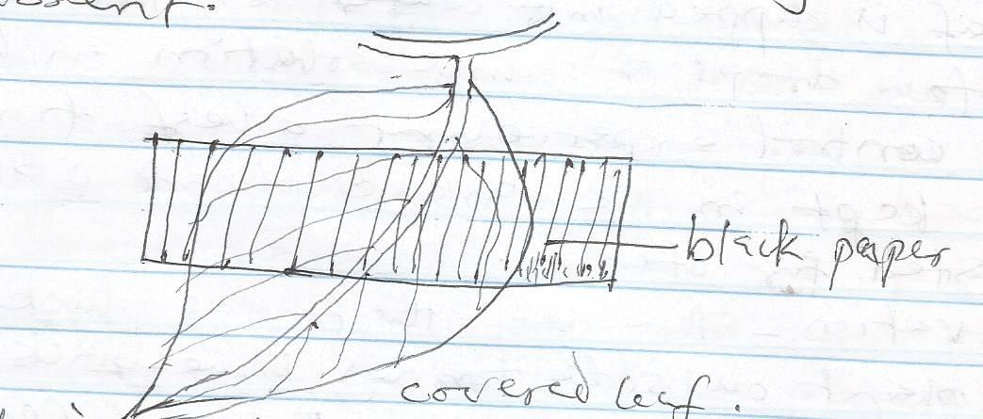

***Conclusion:*** *The experiment shows that sunlight is necessary for photosynthesis*

*Experiment III*

***Aim****: To show that carbon (iv) oxide is necessary for photosynthesis*

***Material Required****: A potted plant, Vaseline, conical flask, split cork, retort stand and caustic soda (sodium hydroxide solution)*

***Method:*** *Use a leaf attached to a potted plant. The leaf is enclosed in the conical flask contains caustic soda solution. The solution will absorbs any traces of carbon (iv) oxide inside the flask. The flask’s mouth is corked and smeared with Vaseline at the neck to make it air tight. The whole experiment is now exposed to sunlight for several hours. Two leaves (one from the flask) and the other outside the flask (control experiment) are plucked and tested for starch.*

***Observation:*** *After testing the leaf inside the flask did not show blue-black colour indicating absence of starch formation because of lack of carbon (iv) oxide inside the flask while the leaf outside has a positive test*

*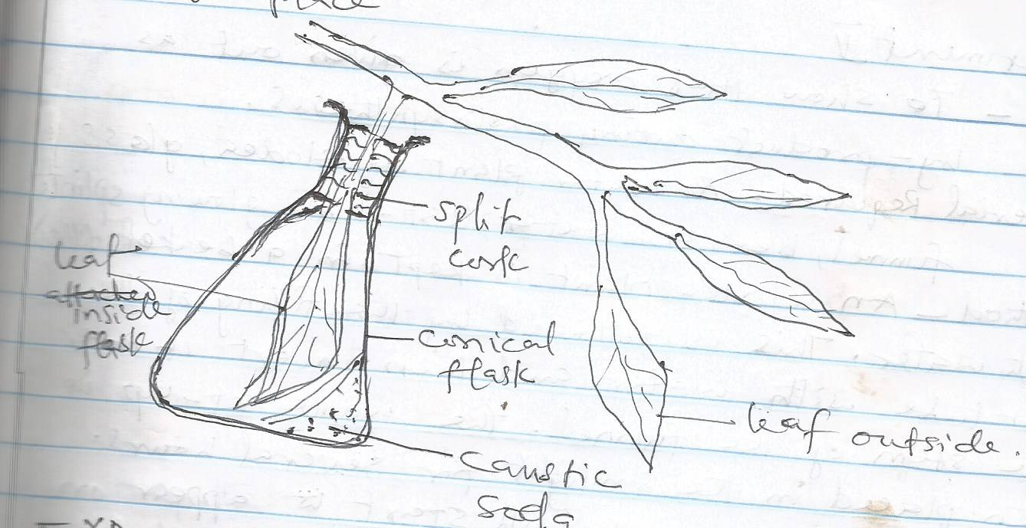Conclusion: The experiment emphasizes the importance of carbon (iv) oxide in photosynthesis to take place*

*Experiment IV*

***Aim****: To show that chlorophyll is necessary for* ***photosynthesis***

***Material*** *Required: A variegated plant like croton, coleus or acalpha plant. A variegated plant has green and white patches on the leaf.*

***Method:*** *The potted variegated plant is exposed to sunlight for about 3-5hours after which a variegated leaf is plucked fresh from the plant during the day time when there is sunlight. The variegated leaf is tested for starch*

***Observation****: It will be noticed that the green plants of the variegated leaf are stained blue black with iodine solution while the parts remain colourless*

***Conclusion****: The experiment shows that chlorophyll is necessary for photosynthesis to take place*

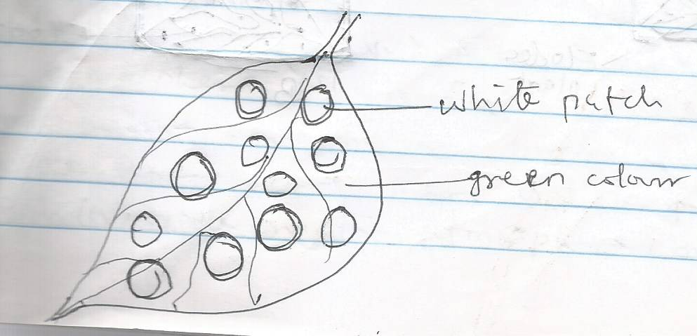

*Experiment V*

***Aim:*** *To show that oxygen is give out as by-product during photosynthesis*

***Material Required****: A water plant e.g. Elodea, glass funnel, beaker, water, test-tube, glowing splinter*

***Method:*** *An elodea plant is kept in a beaker filled with water. This is followed by the filling of the test tube with water and then inverts it over the stem of the funnel. The whole set-up is then placed in the sunlight for several hours. Tiny bubbles of gas will start to appear on the surface of the leaves and accumulate at the top of the test tube. The gas is tested with a glowing splinter*

***Observation:*** *It will be seen that the gas formed at the top of the tube rekindles glowing splinter showing the presence of oxygen.*

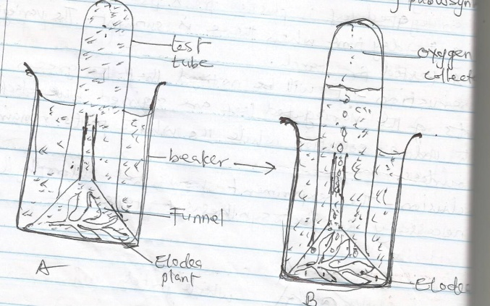***Conclusion:*** *The experiment shows that oxygen is given off a by-product during photosynthesis*

***ASSIGNMENT***

***WEEK FIVE***

*1a. Define Photosynthesis?*

*b. Describe the light reaction stage*

*c. Explain how photosynthesis occur in green plant*

*d. List five conditions necessary for photosynthesis*

***WEEK 6***

***NUTRIENT CYCLING IN NATURE***

*Nutrient cycle is defined as the circulation of certain nutrient such as carbon, sulphur and water in nature*

***Carbon Cycle***

*The carbon cycle is the way carbon (iv) oxide is being used from the atmosphere by photosynthesis and put back into the atmosphere by respiration and decay. The carbon cycle involves the following processes Photosynthesis, Respiration, Putrefaction and Combustion. Only photosynthesis removes carbon (iv) oxide from the atmosphere, the other three processes return carbon (iv) oxide to the atmosphere*

*1.* ***Photosynthesis:*** *The air contains carbon (iv) oxide which diffuses into the leaves and it built up into sugar and other complex compound. When the plant is eaten by animal, sugar gets into the cells in the animals body.*

*2.* ***Respiration:*** *Within the animal body when the chemical food substance is broken down, it releases carbon (iv) oxide, water and energy. The carbon (iv) oxide is released to the atmosphere.*

*3.* ***Putrefaction****: When animals and plants die, they decay. In the process of decay, bacteria and other microbes feed on them. The bacteria and other microbes too respire therefore returning C02 back to the atmosphere*

*4.* ***Combustion****: carbon (iv) oxide is also released into the atmosphere when fuels such as coal, wood, petrol, kerosene are burned*

*5.* ***From the sea****: Where there is little quantity of carbon (iv) oxide in the atmosphere, more is liberated from the seas. Conversely when there is too much carbon (iv) oxide in the atmosphere, more dissolve in the sea*

***Importance of Carbon cycle***

*i. All living things are made up of carbon component*

*ii. All food components contain carbon in item*

*iii. The process produces carbon (iv) oxide for the use of photosynthesis*

*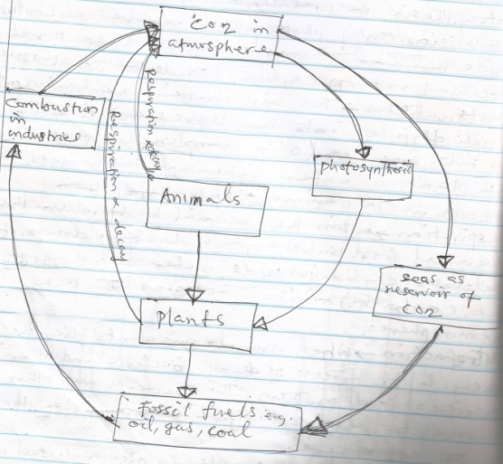iv. The process maintain carbon oxygen balance in the atmosphere*

***WATER CYCLE***

*The water cycle is defined as the way water is being used and being returned to the atmosphere in form of water vapour to fall back as rain. The water cycle involves two processes namely condensation and evaporation. When rain falls, some of it is absorbed by plants through their root hairs. After spending sometime in plants, water evaporates from them in the process of transportation. A lot of the water is drunk by animals which they use to release water vapour to the environs during respiration and excretion. Some of the rain falls directly into pond, stream and rivers. Some of the water filters down through the soil and form underground water empties into the oceans. Water returns to the atmosphere by evaporation. When water vapour accumulates into the atmosphere as cloud when it has reached condensation level which may fall once again as rain.*

***Importance of water to plant***

*i. it cools the plant during the process of transportation*

*ii. It serves as an agent of weathering for soil formation*

*iii. It aids germination of seeds*

*iv. It helps to dissolve plant nutrient for easy absorption by plant*

*v. Water is required for photosynthesis to commence*

*vi. It gives plant support through rigidity*

***Importance of water to animal***

*i. It is the main component of animal*

*ii. It is the solvent for soluble food substance to dissolve during digestion*

*iii. It is a medium of transportation for nutrient*

*iv. It constitutes a large part of the blood*

*v. it aids excretion and regulate body temperature*

*vi. It is the basis for the body secretions such as hormones and enzymes*

*vii. It is the medium in which biochemical reactions can take place in living organism.*

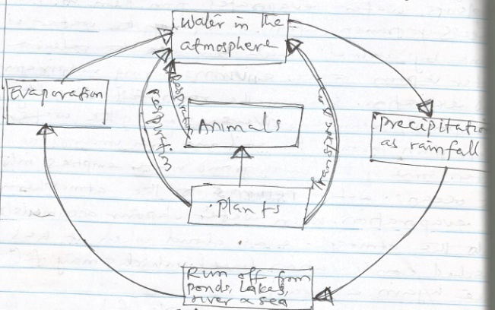

***ASSIGNMENT***

***WEEK 6***

*1. Name the constituent elements, two food sources and two function of each of the following*

*a. Carbohydrate*

*b. Protein*

*c. Lipid*

*2. What is an enzyme?*

*b. What are the characteristics of an enzyme?*

***WEEK 7***

***ANIMAL NUTRITION (FOOD SUBSTANCES)***

*Food is a complex energy-rich organic matter which living organism feed on to obtain nutrients and substances necessary for life. Food substances are classified to six groups*

*(i) Carbohydrate (ii) Protein (iii) Fat and oils (iv) Mineral salts (v) Vitamins (vi) Water and roughages.*

***Carbohydrates*** *are made up of carbon, hydrogen and oxygen. They have general formula* ***(CxH2O)y****. carbohydrate consists of simple sugar, starches, cellulose and glycogen. They are grouped into simple sugar or monosaccharide, double sugar/disaccharides and poly saccharide. The common sources include yam, cassava, potatoes, bread, cereals e.g. rice, maize e.t.c.*

***Simple sugar or Monosaccharide***

*These are the simplest sugar which consists of one molecule of simple sugars. They have general formula C6H10O6. Examples are glucose, fructose and* ***ribose (C5H10O5****) or galactose*

***Disaccharide/Reducing sugar***

*These are sugars which consist of two molecules of simple sugar which formed by condensation with the general formula* ***C12H22O11****. Examples are sucrose, maltose and lactose*

***Sucrose****: It is a non-reducing sugar which is formed from a molecule of glucose and a molecule of glucose is the main source*

***Maltose:*** *This is obtained from the condensation of two molecules of simple sugar. It is reducing sugar*

***Lactose*** *(milk-sugar): It is a reducing sugar. It is obtained from the condensation of a molecule of glucose and a molecule of galactose*

***Polysaccharide***

*These are complex carbohydrates. Examples are starch, cellulose, chitin and inulin.*

*1.* ***Starch****: It has the formula C6H10O5)n where n represent a large number. It is formed from the condensation of numerous molecules of simple sugar. Examples of the sources of starch are yam, cereals, cassava and bread*

*ii.* ***Cellulose:*** *This is composed of several condensed unit of monosaccharides. It makes the cell wall of plant source of cellulose include whole meal bread, cereals, fresh fruit and vegetables.*

*iii.* ***Glycogen (Animal starch****): This is the form which animals store their carbohydrate usually in the muscle or liver*

***Importance of Carbohydrate***

*i. It provides energy required by animals for their daily activities*

*ii. It provides heat during it oxidation used in maintain the body temperature*

*iii. It forms certain body part of arthropods (exoskeleton)*

*iv. The mucus which is an important lubricant in the body is formed carbohydrate*

***PROTEIN***

*Proteins are complex molecules and are made of smaller unit called amino acids. Proteins have to be digested to amino acids before they are absorbed in the body of animal. The breakdown of proteins during digestion takes place in the following*

*Protein Peptone Polypeptide Amino acid*

*Protein is composed of carbon, hydrogen, oxygen, phosphorus and sulphur*

*Sources of protein include both animal source and plant source*

*The animal source includes milk, egg, fish, cheese, meat and chicken while the Plant sources are beans, groundnut, soya beans and melon.*

***Importance of Protein***

*i. Protein is needed for growth of young ones*

*ii. It is used for the repair of worn out tissues or cells*

*iii. It aids reproduction*

*iv. It is used for the production of enzymes*

*v. It is needed for the production of hormone*

*vi. It is needed for body building57*

***FATS AND OIL***

*Fat and oils are also called lipids. They consist of only carbon, hydrogen and oxygen. However, the amount of oxygen in each lipid is very little e.g. tristearin, is C57H10O6. Fats are solid lipid at room temperature. Plant sources of oil include groundnut, palm oil, soya beans oil; coconut oil and melon oil white animal sources of fat include butter, fish or cod oil.*

*Fat and oil are hydrolysed during digestion to fatty acid and glycerol*

***Importance of Fat and Oil***

*i. Fat and oil provides more energy to animal than carbohydrate*

*ii. Fat supplies essential fatty acid to animal*

*iii. Fat and oil act as solvent for fat soluble vitamins*

*iv. They help in the maintenance of body temperature*

*v. They act as insulator to animal which help them to conserve heat*

***MINERAL SALT***

*Mineral salts are food substances that are required in traces for vital body process. They are taken in their ionic forms. Animal takes in their elements mainly by feeding on plants or their products except a few of them such as sodium chloride (table salt). Lack of mineral salts will result in nutritional deficiency. These mineral elements or salts include phosphorus, calcium, iodine, manganese, fluorine, copper and cobalt.*

|  |  |  |  |
| --- | --- | --- | --- |
| *MINERAL* | *SOURCE* | *FUNCTIONS* | *DEFICIENCY SYMPTOMS* |
| *CALCIUM* | *Milk, Cheese, Egg and Fish* | *(i) Bone and teeth formation and development*  *(ii) Needed for blood clotting*  *(iii) Normal Functioning of the heart, nervous system and muscle* | *(i) Rickets*  *(ii) Osteomalacia*  *(iii) Tooth decay* |
| *PHOSPHORUS* | *Milk, cheese, egg, fish and wheat* | *(i) For strong development of teeth and bone*  *(ii) It forms part of DNA and RNA*  *(iii) Needed for respiration* | *i) Rickets*  *(ii) Osteomalacia*  *(iii) Tooth decay* |
| *MAGNESSIUM* | *Green, vegetables, milk, meat* | *(i) For muscle contraction*  *(ii) Needed for utilization of iron*  *(iii) Needed for teeth and bone* | *Nervous disorder* |
| *POTASSIUM* | *Fruits and other Natural food* | *(i) Needed for functioning of the muscles*  *(ii) For transmission of impulses in nerves* | *It leads to muscle paralysis* |
| *SULPHUR* | *Beans, fish, meat & egg* | *Constituent of proteins, amino acids and vitamin B* | *Poor growth* |
| *SODIUM & CHLORINE* | *Table salt, fish fruit* | *(i) Transmission of impulses*  *(ii) Maintenance of osmotic balance of the cell* | *(i) Dehydration*  *(ii) Muscle cramp* |
| *IRON* | *Eggs, liver, kidneys, beans, vegetables* | *(i) Formation of haemoglobin in red blood cell* | *Anaemia* |
| *IODINE* | *Sea foods* | *(i) Required by the thyroid gland to make thyroxine* | *Goitre* |
| *MARGANESE* | *Egg, Milk, Meat* | *(i) Required for normal growth*  *(ii) Acts as co-factors in some enzymatic reactions* |  |
| *COPPER* | *Green vegetables, eggs, milk, meat* | *(i) It catalyses the use of iron*  *(ii) For proper respiration in some aerobic organisms* | *Anaemia* |

***VITAMINS***

*Vitamins are organic food substances which are needed in small quantities or traces for body normal growth and healthy development in man and other animals. Absence or insufficiency of vitamin supply in diet may lead to deficiency diseases*

*Groups of Vitamins*

*(i) Fat Soluble Vitamins: These are vitamins that are soluble only in fat e.g. vitamins A,D, E and K*

*(ii) Water Soluble Vitamins: These are vitamins that are soluble in water e.g. vitamins B-complex and vitamin C. some members of vitamin B2(Riboflavin), B3 (Niacin), b5 (Pantothenic) B6 (Pyridoxine), B12, (cyanocobalamine), Folic acid e.t.c.*

|  |  |  |  |
| --- | --- | --- | --- |
| *VITAMIN* | *SOURCE* | *FUNCTION* | *DEFICIENCY/SYMPTOMS* |
| *VITAMIN A*  *(Retino)* | *Liver, eggs, fish, milk, palm oil, fresh vegetables* | *(i) Required for normal growth of cells and skin*  *(ii) For proper vision of the eye* | *(i) Night blindness*  *(ii) Reduced resistance to diseases* |
| *VITAMIN B1* | *Yeast, unpolished rice, milk, beans, palm wine* | *(i) Required for normal growth*  *(ii) Formation of co-enzymes involved in cellular respiration* | *(i) Slow growth*  *(ii) Dermatitis* |
| *VITAMIN B2* | *Yeast, soya beans, egg, milk, green vegetables* | *(i) Required for growth healthy skin and proper functioning of the eyes*  *(ii) Formation or co-enzymes involved in cellular respiration* | *(i) Slow growth*  *(ii) Dermatitis* |
| *VITAMIN B3* | *Yeast, beans, milk, palm wine, yam, vegetables* | *Needed for cellular respiration* | *Pellagra ( a skin disease and digestive problem* |
| *VITAMIN B12* | *Kidney, liver, fish, milk* | *Formation of red blood cells* | *Pernicious anaemia* |
| *VITAMIN C*  *(Ascorbic acid)* | *Fresh fruits e.g. Orange and green vegetables* | *(i) Aids wound healing*  *(ii) Helps to resist infection* | *Scurvy (characteristic by bleeding gum, poor healing of wood an low resistance of infection)* |
| *VITAMIN D*  *Calciferol* | *Fish, milk, egg, liver, form in the skin by light* | *Needed for strong bone and teeth formation and development* | *Ricket, osteomalacia* |
| *VITAMIN E (Ergo sterol)* | *Green vegetable, butter, liver* | *Promotion of fertility in animals* | *Reproductive failure e.g. sterility and pre mature abortion* |
| *VITAMIN K*  *Phylloquinone* | *Fresh green vegetable/cabbage spinach* | *Aids blood clothing* | *Haemorrhage* |

*WATER*

*Water is composed of two elements hydrogen and oxygen. Source of water available to animals include metabolic water from food, drinking water from rivers, rain, pond e.t.c.*

*Importance of Water*

*(i) It is required for metabolic activities in the body*

*(ii) Water is necessary for digestion of food*

*(iii) It can be used for maintenance of body temperature*

*(iv) It is served as a medium of transportation of nutrients*

*(v) It helps in excretion of metabolic waste products from the body e.g. urine*

*(vi) It is the basis of body secretion from endocrine gland*

*(vii) It helps in the maintenance of the osmotic content of the body*

***BALANCED DIET***

*This is a diet containing the correct proportion or the right amount of all six food substances required by an organism. The balanced diet must contain the six food classes such as carbohydrate, proteins, fats and oil, minerals, vitamins and water*

***DIGESTIVE ENZYMES****: are organic catalyst which are complex protein substances that are manufactured by living cells. They accelerate metabolic reactions without changing their composition in the process. Enzymes are produced by both plants and animals. Enzymes may be named according to the process in which they are involved processes like photosynthesis, respiration and digestion and enzymatic in nature.*

***Characteristics of Enzymes***

*(i) Enzymes are specific in their actions*

*(ii) Only small quantity of an enzyme is required to catalyse a reaction*

*(iii) Enzymes have a specific temperature range above or below which they work become inactive or denatured. They work best at about 370c*

*(iv) Enzymes do not lose their chemical composition at the end of a reaction*

*(v) Enzymes are affected by the acidity and alkalinity (PH) of a medium. An enzyme which is active in an acidic medium e.g. pepsin become inactive in alkaline medium and vice versa.*

*(vi) Enzymes are usually involved in reversible reaction*

*(vii) Enzymes are produced by glands of the system that require that activities e.g. digestive enzymes are produced by various gland of digestive system*

*(viii) Substance called inhibitor can stop the activities of enzymes*

*(ix) The activities of enzymes can be enhanced when they are joined to a co-enzymes e.g inorganic subsistence such as phosphorus.*

***CLASSES OF ENZYMES***

1. *PROTEASES- These are protein digesting enzymes. They are present in the stomach e.g Renin and Pepsin and also in the duodenum (Trypsin) and ileum (Erepsin). They all digest protein and break them into smaller unit.*
2. *AMYLASE- They are enzymes which digest starches and sugars and convert them to glucose. Ptyalin or Salivary amylase is produced by salivary gland in the mouth. It can converts starch to maltose.*

*Pancreatic amylase is produced in the pancreas. It converts starch to maltose, sucrose and lactose. It also converts these double sugars to their final products. Maltose to glucose, sucrose to fructose and glucose and lactose to galactose and glucose.*

1. ***LIPASES****- These are enzymes which convert and oils to fatty acid and glycerol. They are produced in the pancreas and ileum.*

*Digestive enzymes and functions*

|  |  |  |  |  |
| --- | --- | --- | --- | --- |
| *Enzymes* | *Sources* | *Location* | *Substrate acted upon* | *Effect/product* |
| *Ptyalin* | *Salivary gland* | *Mouth* | *Starch* | *Partial hydrolysis of starch to maltose* |
| *Renin* | *Gastric gland* | *Stomach* | *Proteins* | *It coagulate or curdle milk* |
| *Pepsin* | *Gastric gland* | *Stomach* | *Proteins* | *It convert solid protein to peptones* |
| *Pancreatic Lipase* | *Pancreas* | *Duodenum* | *Fat and oils* | *It converts fat and oils to fatty acid and glycerol* |
| *Amylase* | *Pancreas* | *Duodenum* | *Starch* | *It converts starch to maltose* |
| *Trypsin* | *Pancreas* | *Duodenum* | *Proteins or peptones* | *It converts proteins or peptones to polypeptide* |
| *Erepsin* | *Succus entricus* | *Small intestine* | *Poly peptide* | *It converts polypeptide to amino acid* |

***ASSIGNMENT***

***WEEK SEVEN***

*1a. Define enzyme*

*b. State 5 characteristics of enzymes*

***WEEK EIGHT***

***MODE OF NUTRITION***

*1****. Autotrophic Nutrition*** *is the type of nutrition in which the organisms are able to manufacture their own food. Organisms which can manufacture or synthesize their own food are called autotrophs. Autotrophic nutrition is carried out by all green plants through the process of photosynthesis and by some certain bacteria through the process of chemosynthesis*

*2.****Heterotrophic Nutrition*** *is the type of nutrition in which organisms cannot manufacture their own food but depends directly on plants for their own food such organisms are called heterotrophs, most heterotrophs are fungi, protozoa and some bacteria*

*There are various types of heterotrophic nutrition as follows*

*1.* ***Holozoic Nutrition****: This is the type of nutrition in which solid complex food substances are ingested and changed them into simple, soluble form during digestion. The processes involved holozoic nutrition includes ingestion digestion, absorption, assimilation and egestion. These processes are applicable to simple animals from protozoans such as Amoeba and Paramecium to complex organisms including man.*

*2.* ***Parasitic Nutrition or Parasitism****: This is an association between the organisms of different species in which the smaller organisms called parasite depend on the larger partner called host for food and nutrients at the expense of the host i.e. causing harm and diseases to the host. For example association between round worm and man. Parasitic nutrition is also seen in plant where the plant parasite develops haustoriun with which it absorbs nutrient from the host cassytha and cuscuta (dodder plant). Other are phytophtora black pod parasite of cocoa.*

*3.* ***Symbiotic Nutrition or Mutualistic Nutrition****: This is a type of nutrition in which two organisms of different species live together to derive mutual benefit from their association. The partners may be a plant to plant, animal to animal e.t.c. examples of organism that engage in symbiosis are lichens (an association of algae and fungus partnership). The green alga manufactures food for both organisms while the fungus protects the alga and absorbs water from the atmosphere for the use of alga. Another example is hermit crab inhabiting on molluscian shells carry other organisms on the skills. The organism may be a group of sea anemones which afford concealment protection for the crab and themselves obtain transport, better oxygenation and possible particles floating up while the crab is feeding.*

*4.* ***Saprophytic Nutrition****: This is a form of feeding in which the organism derives its food from the remain of dead and decaying organic matter such as plant and animal. The organism is called saprophyte while the process is called saprophytism. This mode of nutrition is exhibited by some bacteria, fungi and some animals. Saprophytes secrete digestive enzyme onto the substrate (the organic matter) on which they feed digestion take place outside the organism. This type of digestion is called extra cellular digestion and it is the process that causes the decay. The extracellular enzymes the organism released to the food surface act only in the presence of moisture and the chemical reactions are usually being speeded up by a rise in the temperature.*

***COMMENSALISM***

*Is an association between the organisms of different species in which only one partner benefit from the relationship while the other neither gains nor suffer any harm. For example, the association between shark and remora fish.*

***CARNIVOROUS PLANT***

*These are plants which apart from being autotrophic and photosynthetic feed on insect or small animal to supplement their protein needs. These insectivorous plants are found in nitrogen poor habitats, and they do trap insects as source of nitrogen. The insects are attracted by their colour, scent or sweet secretion (nectar) of the plants. They also have enzymes with which they digest the insects before being absorbed into their body. These plants include Venus fly trap (Dioaea), sundew plant(Drosera), the pitcher plant(Nepenthes) and bladderwort (urtricularia).*

***FILTER FEEDING***

*Filter feeding is feeding mechanism being used by some aquatic animals to feed on tiny microorganisms in the water called phytoplankton (plant) and zooplankton (tiny animal).These aquatic animals have to wallow in water through sieve-like structure on their body in order to collect large quantity in the water current. Examples of filter feeders are mosquito larva, mussels, duck, prawn, lobster etc.*

***FLUID FEEDING***

*Fluid feeding is a method of feeding adopted by some animals which involve feeding on fluid material from plant (nectar) or blood of animals or man. They have special mouth parts for piercing the skin of their prey e.g. mosquito. Other insects such as aphids feed on the sap of plant whose mouth part is for piercing and sucking. Some larger animals such as bees, butterfly and humming birds suck the nectar of flowers.*

***ASSIGNMENT***

***WEEK EIGHT***

*1. Explain the following mode of nutrition*

*i. Commensalism ii. Parasitism iii. Symbiotic iv. Holozoic*

*2 Explain i. Fluid feeding ii. Filter feeding*

***WEEK NINE***

***BASIC ECOLOGICAL CONCEPT***

***Ecology*** *is the study of living organisms (plants and animals) in relation to their environment. Ecology is divided into two main branches.*

1. ***AUTECOLOGY****- is the study of an individual organism or a single species of organism and its environment. For example, the study of a single and its environment.*
2. ***SYNECOLOGY****-is the study of the inter-relationship between groups of organisms or species of organisms living together in an area. For example the study of different organisms in a river in relation to their aquatic environment.*

***ECOLOGICAL CONCEPT***

***HABITAT****- is defined as any environment which an organism lives naturally e.g. Fish lives in water, land, air and trees.*

***ENVIRONMENT-*** *is the overall factor external and internal, living and non-living which effect on the organism.*

***ECOSYSTEM****-is defined as the association between living components (plant and animals) with the non-living factors of the environment.*

***COMMUNITY*** *of organism consist of the population of different kinds of organisms living together in an area or habitat.*

***BIOMES*** *are large easily recognizable terrestrial ecosystems consisting of plants and animals naturally living together.*

***BIOSPHERE OR ECOSPHERE*** *is the zone of the earth occupies by living organisms. It is a layer of life which exists on the earth surface.*

***LITHOSPHER****E is the solid portion of the earth. It is the outermost layer or zone of the earth crust. It is made up of rocks and minerals materials.*

***HYDROSPHER****E is the liquid or aquatic part of the earth of the earth or living world. It holds water in various forms e.g. solid (ice), Liquid (water) and as gases. Examples of hydrosphere are lake, pools, spring, ocean or sea, ponds, oasis, river and stream.*

***ATMOSPHERE-*** *This is the gaseous portion of the earth. It is a layer of gases surrounding the earth.*

***ECOLOGICAL NICHE*** *is defined as the specific portion of the habitat which is occupied by a particular species or organism. It is the functional position of an organism in the community for examples; a caterpillar and aphid which lives on the same plant occupy different position or ecological niche on the plant.*

***POPULATION i****s defined as the total number of organisms of the same species living together in a given area. For example, the total number of Tilapia fish in a pond constitutes the population Tilapia in that habitat.*

***Component of Ecosystem***

*The ecosystem comprises of the biotic component and abiotic component.*

*1****. Biotic factor/component*** *includes all living organisms in the environment often called biotic community. The biotic population include:*

1. *Food producer (autotrophs) e.g. green plant, protophyta and chemosynthetic bacteria*
2. *Food consumer (heterotrophs) e.g. herbivore, carnivore and omnivore, protozoa and some bacteria.*
3. *The decomposers are organism that cause the decay of dead plant and animals e.g. saprophytes such as fungi and bacteria*

*The abiotic factors/component is the non-living factors in the physical environment. They are what organisms need to stay alive. These factors include soil, water, temperature, humidity, light intensity, air minerals salts etc. The abiotic factors control the activities of the biotic component just as the organism also influence and control the abiotic environment.*

***ASSIGNMENT***

***WEEK NINE***

*1a. Define the following*

* *Ecosystem*
* *Niche*
* *Biosphere*
* *Population*
* *Habitat*

*b. List the three components of ecosystem*

***WEEK TEN***

***GROWTH***

*Growth is defined as an irreversible increase in volume, size, and number of parts, length and weight of an organism It is an organic process which takes sometimes to accomplish.*

*The three processes involve in growth are*

*1.* ***Cell division****:- is a process by which cell increases in number and is achieved by cell division called mitosis. The synthesis of new protoplasm leading to the doubling of the chromosomes number in a process called replication before cell actually divide into two, with each daughter cell having the same chromosome as parent cell.*

*2.* ***Cell enlargement****:- This is a process after cell division in which the daughter cell absorb nutrients from their surrounding which it uses to increase in mass and size. Part of the nutrient is used to generate energy while the remaining is assimilated resulting in enlargement of the cells.*

*1.* ***Cell differentiation****- This process takes place after cell enlargement in which each cell develop into a special type of cell by changing its shape and structure in order to carryout growth, a specialized or particular function.*

***MITOSIS***

*Mitosis is a division of cell which produces two identical cells with the same number of chromosomes and characteristics as those of the parent cell. Mitosis is a cell division that lead to growth and it occurs in somatic cell(body cells) such as skin, bone marrow, lymph nodes and injured places and meristimatic tissues of plant. Mitosis occurs in five stages namely interphase, prophase, metaphase, anaphase and telephase.*

1. ***Interphase-*** *This is a resting stage of the cell: At this stage, the cell has normal appearance of non-dividing cell condition. Chromosomes are not clearly visible.*
2. ***Prophase-*** *The chromosomes become visible as chromatin threads. The chromosomes become shorter, thicker and clearly visible. Each chromosome now forms two district chromatids joined by a centromeres.*

*Nucleolus is gradually disappearing and formation of spindle fibres commence.*

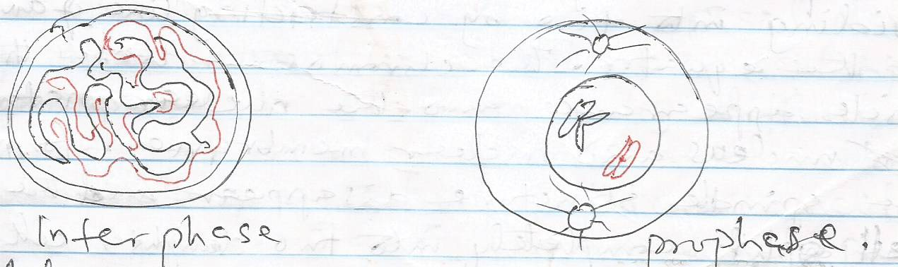

*`*

1. ***Metaphase****- At metaphase the chromosomes (now parried) called chromatids arranged themselves along the equator or middle of the spindle. The chromatids are attached to the spindle by centrometre.*

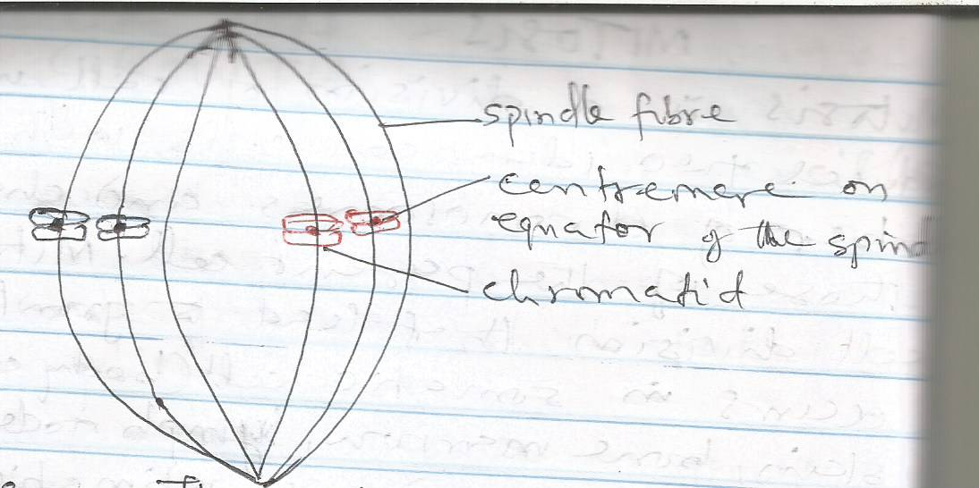

1. *Anaphase- The chromatids of each chromosome separate. The start migrating to the poles of the cell by elongation of the spindle axis. The chromatids eventually reach the pole.*

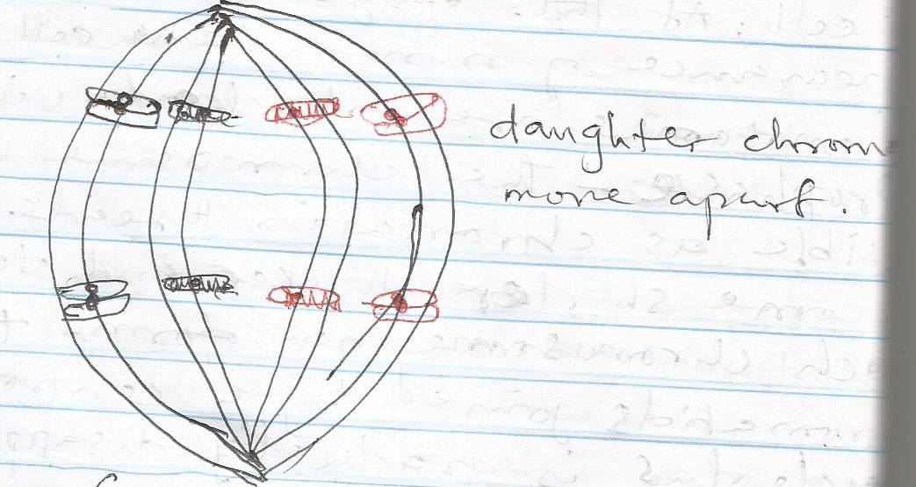

1. ***Telophase*** *(cytokinesis)- The cell starts dividing into two by line of division at the equator. The chromosome loses their thick appearance and the nuclear material, nucleus and nuclear membrane reformed. The spindle structure disappears and the cell split completely into two daughter cells having the same condition as interphase. The*
2. *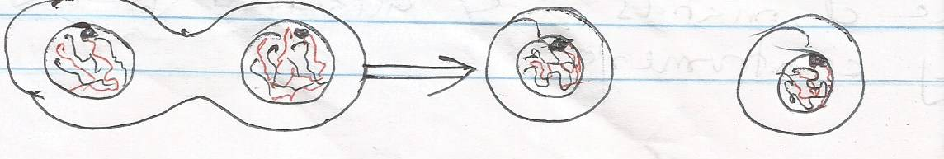division of the cell at telophase into daughter cells is called cytokinesis*

***Aspect of Growth***

*Growth does not occur any how in all parts of the plant. It takes place in certain tissue and places in a plant bodies. The tissue where growth takes place plant is called meristem or meristematic tissue. A meristem is a tissue that retains their ability to divide by mitosis and turn out new cells. Such meristematic tissues include root apex, stem or shoot apex base or internodes and vascular cambium.*

*Growth which occurs in the apical stem and root meristem is called apical growth while growth which occurs at meristem base of internodes is called auxiliary growth*

***Regulation of growth by Hormones***

*Hormones or chemical or biochemical substances produced in small quantity by cell of the body of plant and animal that has profound effect on other part of their body where they are needed for some form of growth*

*Plant hormones are produced only at the growing parts such as apical meristem of shoot or root i.e. shoot tip or root tip and transported to other part by diffusion.*

*Examples of plant hormones are auxin, gibberellin, cytokinin, abscissic acid and florigens. Plant hormones help plant in the following ways.*

*i. It promotes stem elongation*

*ii. It makes plant to respond to tropism*

*iii. It causes root and stem apical division*

*iv. It causes fruit growth and ripening*

*v. It causes flower bud and lateral root initiation*

*Animal Hormones*

*In animal, hormones are produced in ductless glands called endocrine system and release straight to the blood stream which transport them to the target organ. Animal hormones include the following*

*GLANDS SITE HORMONE*

*1. Pituitary gland base of head Pituitrin*

*2. Thyroid gland Neck Thyroxine*

*3. Parathyroid Neck Parathormone*

*4. Pancreas Loop of duodenum Insulin*

*5. Adrenal gland Top of each kidney Adrenaline*

*6. Testes Testes Testosterone*

*7. Ovaries Ovaries Progesterone*

*FUNCTION OF ANIMAL HORMONE*

*i. It controls body metabolism*

*ii. It promotes growth of the animal*

*iii. It induces or stimulates reproduction*

***IRRITABILITY***

***Irritability*** *is the ability of an organism to perceive and respond to changes in internal and external environment or stimuli. Stimulus is a change in condition which produces a change in the activities of the organism or part of its body. A stimulus can either be external or internal. External stimuli are those environmental factors that evoke response. Organisms respond to stimulus in three ways namely tactic, nastic and trophic response.*

***Tactic Response or taxis*** *is a directional type of response or movement in which the whole organism moves from one place to another in response to external stimulus such as light, temperature, water or certain chemical. The response is thus said to directional and positive if the organism moves towards the stimulus or it is negative if it moves away from the stimulus.*

*- Phototaxis is the response to variation in light intensity*

*- Chemotaxis is the response to variation in concentration of chemical substance*

***Nastic Response or Nastism****: This is a type of response in which a part of a plant moves in response to non-directional stimulus such as changes in light intensity, temperature and humidity. Nastic responses are usually described according to the stimulus evoking them.*

*-* ***Nyctinasty is*** *a response to changing in day and night condition (temperature) or light e.g. the opening of the petals of sun flower in the light and closes in the dark*

*- The closing of the morning glory flower when light intensity is low*

***- Haptonasty*** *is the response due to contact or touch*

*- The infolding of the leaflet of mimosa plant when touched.*

*The closing of leaflet of flamboyant tree.*

***Tropic response or tropism****: This is a type of response in which a part of a plant moves in response to directional stimulus.*

*Tropism are growth movement named according to the stimulus e.g. phototropism, hydrotropism, chemotropism, haptotropism or thigmotropism, geotropism.*

***Phototropism*** *is the growth movement in response to light, thus the direction of growth movement depends on the direction of light. The shoot of plant is positively phototropic.*

***Geotropism****: This is a response to gravitational force the shoot of plant is negatively geotropic while the root is positively geotropic.*

***Chemotropism*** *is the response of plant to concentration of chemical substance e.g. roots respond positively to the presence of salt, particularly salt of calcium but negatively to alkaline or acid.*

***Haptrotropism /(Thigmotropism****) is a response of plant to contact and is characteristic of tendrils and other organs by which the plant secures support. Tendrils show positive response to touch by twinkling around a support while roots on the other hand show a negative response to touch by growing away from stones.*

***MOVEMENT***

*Movement is the ability of living organisms to move from one place to another.*

***Reasons for Movement***

*i. To search for food*

*ii To escape from danger*

*iii. To respond to stimulus either positively or negatively*

*iv. For the sake of reproduction*

***CYCLOSIS***

***Cyclosis or cytoplasmic streaming****: This is the mass rotational streaming or movement of the cytoplasm and its contents in cells with the vacuole. In some cases, the streaming may be restricted to a particular region or the cell while at times the whole cytoplasm is subjected to cyclical movement of the cell.*

*Organisms Organelles for movement Mechanism of movement*

*Amoeba Pseudopodia Cytoplasmic streaming (cyclosis)*

*Paramecium Cilia Beating the cilia against water*

*Euglena Flagellum Lashing movement of flagellum*

*Hydra Tentacles Swimming, swaying, hoping and*

*Somersaulting*

*Earthworm Chaetae Crawling*

*Fishes Fins Swimming*

*Toads and frog Limbs Hopping*

***WEEK TEN***

***ASSIGNMENT***

*1. Explain (i) Cell division*

*(ii) Cell enlargement*

*(iii) Cell differentiation*

*2. State the organelles or locomotion in the following organisms*

*(i) Amoeba*

*(ii) Paramecium*

1. *Toad*
2. *(iv) Earthworm*